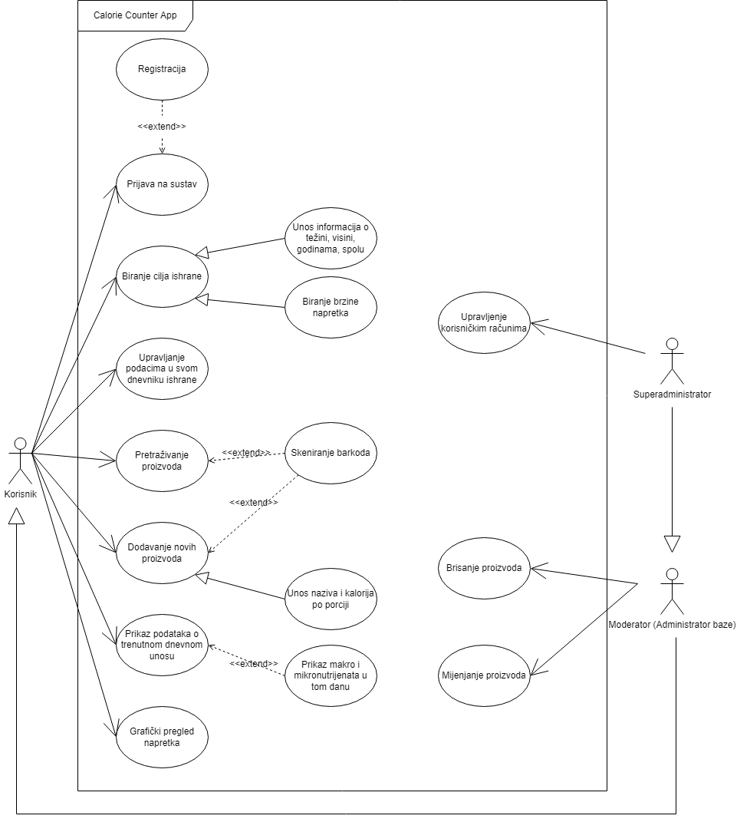

ID: | 1
Title: | Prijava na sustav
Description: | Korisnik se prijavljuje u sustav
Primary Actor: | Korisnik, moderator, superadministrator
Preconditions: | Korisnik se nije prijavio u sustav
Postconditions: | Korisnik je prijavljen u sustav i može nastaviti dalje
Main  Success Scenario: | Korisnik unosi svoje korisničko ime i lozinku, sustav provjerava unesene podatke i ako su ispravni korisniku se daje pristup sustavu.
Extensions: | Ako uneseni podaci nisu ispravni, korisniku se daje do znanja kako je pogriješio i da unese ispravne podatke
Frequency of Use: | Svaki put kada korisnik prvi put pristupa sustavu, ulazna točka sustava
Status: | -
Owner: | -
Priority: | Visok

ID: | 2
Title: | Registracija
Description:
Primary Actor:
Preconditions:
Postconditions:
Main
Success Scenario:
Extensions:
Frequency of Use:
Status:
Owner:
Priority:

ID: | 3
Title: | Upravljanje korisničkim računima
Description:
Primary Actor:
Preconditions:
Postconditions:
Main
Success Scenario:
Extensions:
Frequency of Use:
Status:
Owner:
Priority:

ID: | 4
Title: | Brisanje proizvoda
Description:
Primary Actor:
Preconditions:
Postconditions:
Main
Success Scenario:
Extensions:
Frequency of Use:
Status:
Owner:
Priority:

ID: | 5
Title: | Mijenjanje proizvoda
Description:
Primary Actor:
Preconditions:
Postconditions:
Main
Success Scenario:
Extensions:
Frequency of Use:
Status:
Owner:
Priority:

ID: | 6
Title: | Biranje cilja ishrane
Description:
Primary Actor:
Preconditions:
Postconditions:
Main
Success Scenario:
Extensions:
Frequency of Use:
Status:
Owner:
Priority:

ID: | 7
Title: | Upravljanje podacima u svom dnevniku ishrane
Description:
Primary Actor:
Preconditions:
Postconditions:
Main
Success Scenario:
Extensions:
Frequency of Use:
Status:
Owner:
Priority:

ID: | 8
Title: | Pretraživanje proizvoda
Description:
Primary Actor:
Preconditions:
Postconditions:
Main
Success Scenario:
Extensions:
Frequency of Use:
Status:
Owner:
Priority:

ID: | 9
Title: | Dodavanje novih proizvoda
Description:
Primary Actor:
Preconditions:
Postconditions:
Main
Success Scenario:
Extensions:
Frequency of Use:
Status:
Owner:
Priority:

ID: | 10
Title: | Skeniranje barkoda
Description:
Primary Actor:
Preconditions:
Postconditions:
Main
Success Scenario:
Extensions:
Frequency of Use:
Status:
Owner:
Priority:

ID: | 11
Title: | Prikaz podataka o trenutnom dnevnom unosu
Description:
Primary Actor:
Preconditions:
Postconditions:
Main
Success Scenario:
Extensions:
Frequency of Use:
Status:
Owner:
Priority:

ID: | 12
Title: | Prikaz makro i mikronutrijenata u tom danu
Description:
Primary Actor:
Preconditions:
Postconditions:
Main
Success Scenario:
Extensions:
Frequency of Use:
Status:
Owner:
Priority:

ID: | 13
Title: | Grafički pregled napretka
Description:
Primary Actor:
Preconditions:
Postconditions:
Main
Success Scenario:
Extensions:
Frequency of Use:
Status:
Owner:
Priority:

